In our effort to reduce treatment and conveyance costs and optimize operational efficiency, the Metropolitan Commission is continually seeking ways to reduce the amount of extraneous water that enters the wastewater collection system. This extraneous water, known and Inflow and Infiltration, or I&I, comes from many sources.

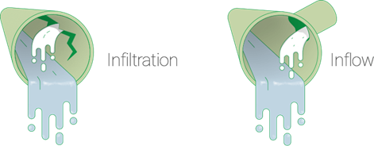
What is I&I? I&I is defined as groundwater and stormwater that enter a sewer system. Infiltration occurs when groundwater seeps into sewer pipes through cracks, leaky pipe joints and/or deteriorated manholes. Inflow is stormwater that enters the sewer system through rain gutters, basement sump pumps or foundation drains illegally connected to the sewer. Together, inflow and infiltration place a burden on collection systems and wastewater treatment facilities. Collection systems can be damaged when they are forced to transport more flow than they are designed to handle. Increased effluent flows also raises costs for wastewater treatment facilities, as treating harmless storm water and groundwater mixed with sewage is inefficient. In some recent storms, the Commission’s treatment plants influent flow have tripled due to the amount of flooding or rainfall that our area has received.
Infiltration occurs when groundwater seeps into sewer pipes through cracks, leaky pipe joints and/or deteriorated manholes. Inflow is stormwater that enters the sewer system through rain gutters, basement sump pumps or foundation drains illegally connected to the sewer.

What happens if there is too much I&I? Exceeding the capacity of the collection system can result in discharge of untreated wastewater into the environment. These spills are referred to as Sanitary Sewer Overflows (SSO’s) and are regulated by the Maryland Department of the Environment. These SSO’s may come from collection system components that are overwhelmed or from a treatment system that does not have the capacity to treat the water. Infiltration can also cause pipe structure failures due to erosion of soil support, and ground subsidence due to erosion of underground soil. The EPA considers infiltration excessive if a system's average dry weather flow is more than 120 gallons per capita per day. This total includes infiltration, domestic flow, and nominal industrial and commercial flows.

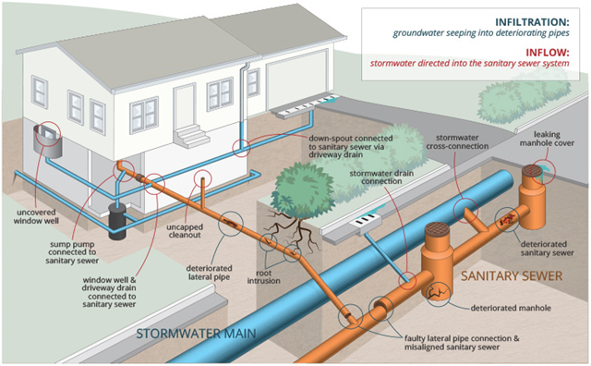
The EPA’s accepted level of excessive of infiltration does not consider regional and seasonal factors like the intensity of precipitation events (such as Tropical Storm Isaias or various tidal surges due to storms) and seasonally varying groundwater levels. For this reason, some states prefer a criterion of gallons per day. An alternate EPA method suggests that system-wide infiltration rates under 1,500 gallons per day per inch of diameter per mile of pipe (gpd/idm) are acceptable. The EPA’s inflow benchmark is 275 gallons per capita per day. MetCom’s thresholds are set at the point when wastewater pump station flows exceed approximately 125% of the dry weather average flow.
Sources of I&I come from a variety of sources. MetCom’s Operations personnel utilize a variety of different strategies to identify, reduce and remediate these sources.

Can you help us reduce inflow and infiltration? Yes, property owners play an important role in reducing sources of I&I. MetCom has been working on reducing I&I in the public sanitary sewers, but it’s only a portion of the entire network of pipes. It’s estimated that over 50% of I&I is from private property. Most property owners do not think about their sanitary sewer laterals until there is a major problem that causes a basement backup. The most effective I&I reduction projects have addressed I&I sources from public sewers and private property laterals. Property owners can:
Inspect and repair damaged sewer service lines.
Do not connect sump pumps to the sanitary sewer.
Do not connect foundation drains to the sanitary sewer.
Keep all cleanouts capped, both inside and outside. This will help keep unwanted water out of the sanitary sewer system and prevent sewer gas from entering your home.
Avoid planting trees/shrubs over your sewer lateral, as tree roots can damage sewer piping.
Ensure that basement drains are not connected to the sanitary sewer and install a sump pump to the stormwater drainage system instead.

What is MetCom doing to reduce I&I? The short answer is a lot. And, with the large network of pipes, reducing I&I is never going to be a “one-and-done” type of project. That is why we are working on establishing a long-term program for I&I reduction. The work, in some ways, will never be completed because it’s about maintaining the sanitary sewer system to an established level of service.

No single solution can fix all the I&I problems. Grouting may be used to stop a leak around a lateral connection at a manhole or leaking joints in pipes. Cured-in-place lining can rehabilitate a sewer pipe or a lateral. Open pick hole manhole covers need to be replaced with solid covers. These are just a few examples of solutions to various I&I sources. First, we have to identify the areas contributing the most I&I and then start investigating them to understand which sources are causing the I&I and what is the best solution to fix the problem.

How does MetCom find where the I&I is coming from? The Operations Department uses several methods to identify sources if I&I, which include:

- Main & Lateral Televising – A robot camera with the ability to record, moves through existing openings in the sewer pipe. These cameras are self-propelled and can inspect the sewer main and lateral at the same time. The cameras are an essential inspection tool for identifying infiltration and inflow, solids accumulation, root infiltration, pipe defects, and the structural condition of lateral services and mainline sewers.

- Manhole Inspections – Traditional inspection methods include visual observation by trained technicians along with the completion of detailed inspection forms and supporting photographs. Advanced techniques include the use of cameras that are remotely operated from a vehicle. The units use a telescoping lowering device, a high-powered camera with a remotely adjustable zoom lens, and powerful lighting. The zoom system allows for digitally recording of the condition of the manhole as well as inspection of pipe segments immediately upstream and downstream of the manhole.

- Smoke Testing – Smoke testing is a relatively simple process that consists of blowing nontoxic, nonflammable smoke mixed with larger volumes of air into the sanitary sewer line. Usually induced through the manhole, the smoke travels the path of least resistance and quickly shows up at sites that allow surface water inflow. Smoke will identify broken manholes, illegal connections (including roof drains, sump pumps, yard drains, and more), uncapped lines, and will even show cracked mains and laterals providing there is a passageway for the smoke to travel to the surface.

- Flow Monitoring – Flow monitoring is an essential procedure to collect data for evaluating and characterizing wet-weather and dry-weather flow conditions in sanitary sewer collection systems. Real-time use of the data for supporting operational decision-making/optimization and in-time maintenance activities.

- Dye Testing – This involves pouring non-toxic fluorescent colored dye down roof drains or catch basins to see if that dye makes its way into the sewer. This provides verification that the storm drainage being tested is directly connected to the sewer.

Are there any restrictions on I&I? The Public Sewer Use Regulations of St. Mary’s County, Maryland §3.8 says that “(n)o person shall make connection of roof downspouts, exterior foundation drains, areaway drains, or other sources of surface runoff or groundwater to a building sewer or building drain, which in turn is connected directly or indirectly to a public sanitary sewer”. It also prohibits “(s)torm water, surface water, ground water, roof runoff, subsurface drainage, swimming pool drainage, condensate, deionized water, noncontact cooling water, unless specifically authorized by the Director”.

Code of Maryland Regulations (COMAR 20.75.06.02) also states that “(r)ain water discharged from roofs, lawns, paved areas, etc., is especially prohibited”. So, we ask that you keep in mind that I&I affects the capacity of our treatment plants and sewer pipes and ultimately, the rate businesses and residents pay to operate and maintain them. The worst impact of I&I is the possibility that the excess sewage flows out of the sewer pipe and into our environment. If ignored, I&I could cost this community millions of dollars.

Questions? If you have any questions or concerns regarding reducing I&I, please call the Operations Department at 301.737.7400 or email us at sewer@metcom.org

