Why do tanks need to be painted? Any steel structure that is exposed to the elements must be maintained to ensure the useful service life is extended for as long as possible. The Commission operates 18 elevated water storage towers and 36 ground storage tanks (both ground storage and pressure tanks). These tanks are constantly impacted by the elements (environmental factors) year-round, which includes exposure to the sun’s UV rays, repeated wet/dry cycles (rain /snow) and temperature fluctuations. Without a preventative maintenance coating, they will degrade and need to be replaced sooner rather than later. The further they degrade, the more costly it is to return them to a serviceable condition. Maintaining these steel water storage facilities is increasingly important in view of rising costs. Water tank painting has traditionally been among the more complex commercial painting services. There is rarely a “good” time for a water tank to be temporarily placed out of service. Often, the requirements of coating application may be in conflict with the real or perceived needs of those who rely on the water tower (toilet use, potable water, pool filling, car washing, lawn irrigation, fire suppression, etc.).

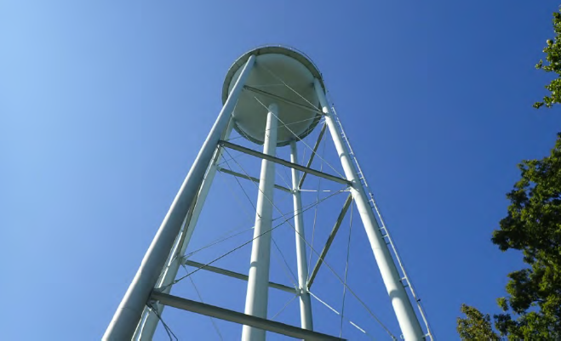
Does MetCom inspect the tanks? The Commission utilizes third party independent contractors to provide inspection services of the elevated water towers and ground based hydro pneumatic water storage tanks. This inspection process evaluates the accessible areas of the substructure, structure (if applicable) and container. Objectives for the inspection team include an overall condition survey, coating evaluation, corrosion analysis and corrosion mapping, a determination of section loss on primary members, and an inspection of critical welded connections. Finally, the tanks are evaluated for operational, safety, sanitary, OSHA and compliance related deficiencies. Information is gathered during the field survey and compiled for the recommendations for repairs and upgrades. In addition, the data would be used to establish an opinion of probable cost for tank rehabilitation. Currently, our tanks are inspected approximately every 8 to 10 years.
Photo 1 Towers are subjected to weather extremes and should be inspected approximately every 8 to ten years.

What does MetCom do with the inspection reports? Based on the results of these inspections, the contracted firm then develops specifications for any recommended modifications, repairs and coating types. The specifications are created to be in adherence with American Water Works Association (AWWA) standards (such as AWWA D100 Standard for Steel Welded Tanks for Water Storage, AWWA D102 Standard for Steel Coatings); the Society for Protective Coatings (SSPC) Systems and Specifications; OSHA/ANSI regulations and the rules and regulations of any other appropriate regulatory agencies. Once these specifications are completed, MetCom staff develops a bid package and solicits bids from qualified vendors.

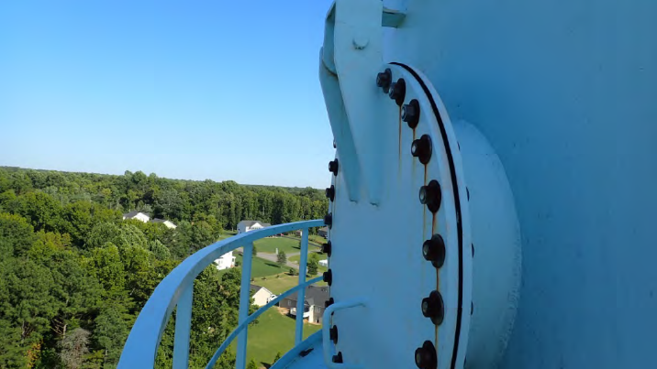
During the rehabilitation process, inspections will occur to ensure all required structural repairs and any sanitary or safety hazards are properly and completely addressed. The inspection will ensure the coatings system manufacturers’ specifications are applied correctly and at the specified thickness. Most of this work is weather-dependent; the optimal times to complete this work is in the spring and fall, this is due to temperatures are moderate and there is less likelihood of condensation forming on the tanks. The tanks are taken offline to perform the specified work, with the exception of the pressure washing of the exterior of the water tower.
Photo 2 The inspection process look at all features on a water storage tank, such as manways and railings.

How is a water storage tank painted? The particulars of the water storage tank painting process depend on the size and location of the system to be painted. Regardless, there are some best practices that MetCom and its contractors adhere to that help ensure all OSHA workplace regulations are followed and the job can get done correctly and safely.

- Tank Inspection. Once a tank inspection is completed, MetCom staff review and evaluate the recommendations of the inspector. We then schedule the required work based on priority and funding availability.

- Coating Selection. The coating and lining materials that METCOM authorizes are intended for use in contact with potable water. These coatings are approved by the US Environmental Protection Agency (USEPA), US Food and Drug Administration (USFDA) as well as meeting NSF/ANSI Standard 61 Drinking Water System Components 61.

- Tower Drainage. Most of this work is weather-dependent; the optimal times to complete this work is in the spring and fall, as temperatures are moderate and there is less likelihood of condensation forming on the tanks. The development of condensation on the exterior could render coating adhesion impossible. Taking tanks off-line at these times of year is also beneficial as these times are outside the primary irrigation months where higher than normal domestic use typically occurs.

- Surface Preparation. The exterior surface may need to be pressure washed, power washed, or sandblasted to ensure the substrate is ready to receive the coating. METCOM will assess the atmospheric and site conditions to decide if it is necessary to deploy a containment shroud at this stage in the process or if it can wait until painting begins in earnest. At the same time, OSHA-compliant scaffolding may be erected as needed.

- Painting. All this preparation ultimately leads to the successful water tank painting. Presuming everything else has been done right, this phase of the work can be completed surprisingly fast.

- Refilling of Tower and Water Quality Testing. Once the coatings have cured and any other work has been completed, the tower will be filled to its operating level. Once the tower is filled, water samples are taken to ensure that there are no residual volatile organic chemicals (VOC’s) within the tower. The tower is then placed back into service.

NOTE: During this process, a 30,000 gallon per day ground storage tank is typically provided to ensure the impacts community / service area continues to have a flow of domestic water, albeit less than they may be accustomed to.

Why do I need to conserve water during the tower painting? When the water storage tank is taken off-line, there will be a reduced storage capacity in that particular water system. METCOM notifies local volunteer fire departments and we will also post signage in the neighborhood prior to the onset of the work.

How can I conserve water when my water tower is offline? Be aware of how much water you use! Awareness is the first step in conservation. During the tower painting process, neighborhoods may have restrictions placed on irrigation, car washing and the filling of pools.
To gauge how much water your household is using conduct a household water audit using the Maryland Department of the Environment guidelines visit CONDUCTING A HOUSEHOLD WATER AUDIT (maryland.gov)

For more information on water conservation tips, please visit Water Conservation Tips for Irrigating Lawns (psu.edu)
If you have any questions or concerns regarding water towers, please call the Operations Department at 301.737.7400 or email us at water@metcom.org

